### 

### Semester Two Examination, 2021

### Question/Answer booklet

# SPECIALIST MATHEMATICS

**UNITs 3 & 4**

## Section One:

## Calculator-free

|  |
| --- |

Your Name

Your Teacher’s Name

## Time allowed for this section

Reading time before commencing work: five minutes

Working time: fifty minutes

## Materials required/recommended for this section

***To be provided by the supervisor***

This Question/Answer booklet

Formula sheet

***To be provided by the candidate***

Standard items: pens (blue/black preferred), pencils (including coloured), sharpener, correction fluid/tape, eraser, ruler, highlighters

Special items: nil

## Important note to candidates

No other items may be taken into the examination room. It is **your** responsibility to ensure that you do not have any unauthorised material. If you have any unauthorised material with you, hand it to the supervisor **before** reading any further.

| Question | Mark | Max | Question | Mark | Max |
| --- | --- | --- | --- | --- | --- |
| 1 |  |  | 5 |  |  |
| 2 |  |  | 6 |  |  |
| 3 |  |  | 7 |  |  |
| 4 |  |  | 8 |  |  |

**Structure of this paper**

| Section | Number of questions available | Number of questions to be answered | Working time (minutes) | Marks available | Percentage of examination |
| --- | --- | --- | --- | --- | --- |
| Section One:  Calculator-free | 8 | 8 | 50 | 51 | 35 |
| Section Two:  Calculator-assumed | 13 | 13 | 100 | 101 | 65 |
|  |  |  |  | **Total** | 100 |

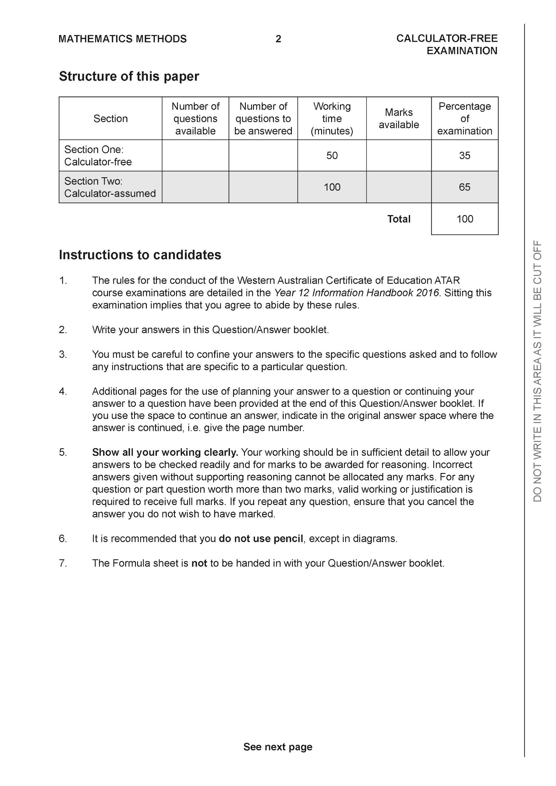

**Section One: Calculator-free (51 Marks)**

This section has **eight (8)** questions. Answer **all** questions. Write your answers in the spaces provided.

Spare pages are included at the end of this booklet. They can be used for planning your responses and/or as additional space if required to continue an answer.

● Planning: If you use the spare pages for planning, indicate this clearly at the top of the page.

● Continuing an answer: If you need to use the space to continue an answer, indicate in the original answer space where the answer is continued, i.e. give the page number. Fill in the number of the question that you are continuing to answer at the top of the page.

Working time: 50 minutes.

**Question 1 (4 marks)**

Evaluate



**Question 2 (6 marks)**

Consider a plane that contains the following points .



1. Determine a normal vector to the plane. (4 marks)
2. Determine a cartesian equation for the plane. (2 marks)

**Question 3 (6 marks)**

Sketch the function on the axes below, labelling important features.

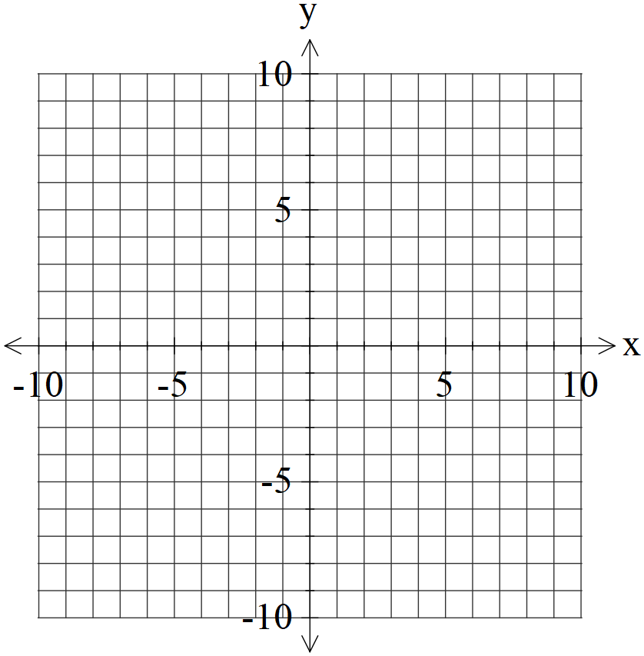

**Question 4 (6 marks)**

1. Solve the following system of linear equations. (3 marks)



1. Solve for all possible values of for the system below for each of the following scenarios. (3 marks)



1. Unique solution.
2. Infinite solutions
3. No solutions.

**Question 5 (6 marks)**

Consider the function drawn below.

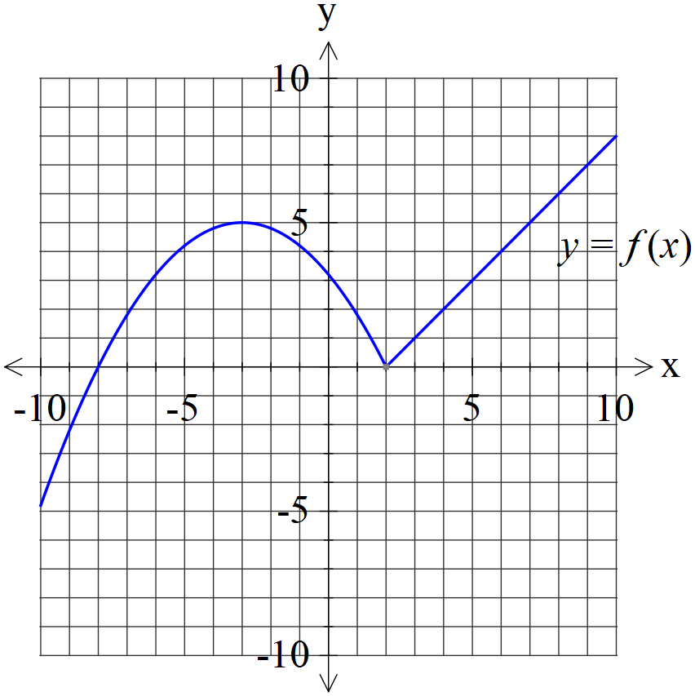

1. Plot on the axes below. (2 marks)

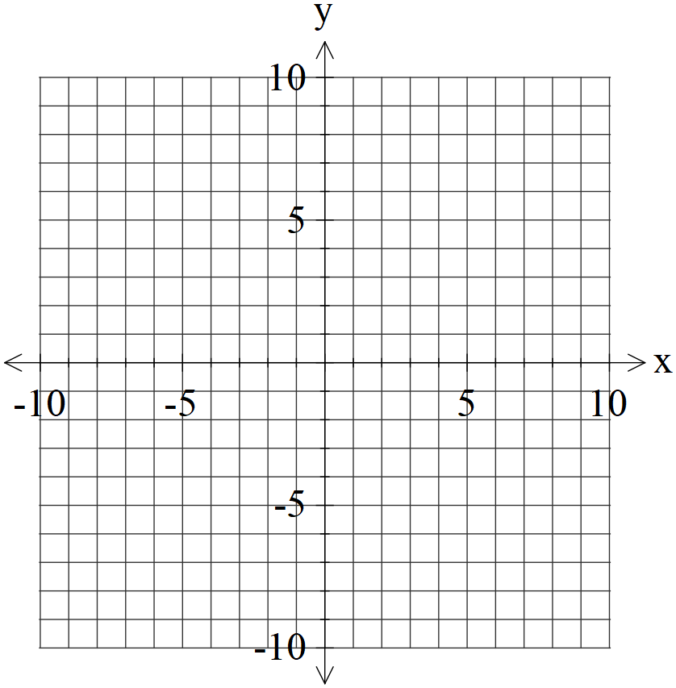

1. Plot on the axes below. (4 marks)



**Question 6 (9 marks)**

Consider the function with domain .



Let .



1. Determine the domain and range of . (2 marks)



1. By using implicit differentiation show that is of the form where is a constant. (4 marks)



1. Evaluate with substitution . (3 marks)



**Question 7 (7 marks)**

1. Given that with constants. Solve for . (4 marks)



1. Hence determine an expression for . (3 marks)



**Question 8 (7 marks)**

Evaluate the following integrals.

1. (3 marks)



1. (4 marks)



**Additional working space**

Question number:

**Additional working space**

Question number:

**Additional working space**

Question number:

**Acknowledgements**